# Task Phase Week 1 Answers (C Programming)

-Anirudh Agrawal

(Reg.No.: 220953044)

Q1] Write a C program to compute the perimeter and area of a rectangle with a height of 20cm and width of 1m.

# Code:

#include <stdio.h>

int main(){

    int h,w,area;

    printf("Enter height of rectangle:");

    scanf("%d",&h);

    printf("Enter width of rectangle:");

    scanf("%d",&w);

    area=h*w;

    printf("The area of rectangle is: %d",area);

    return 0;

}

# Output:

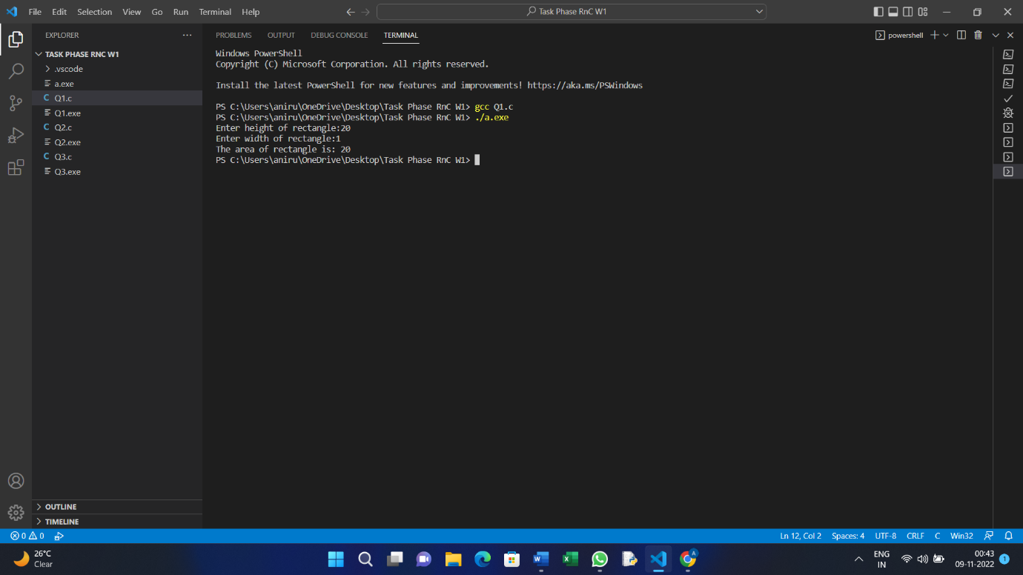

Q2] Write a C program to find the third angle of a triangle if two angles are given.

# Code:

#include <stdio.h>

int main(){

    int a1,a2,a3;

    printf("Enter angle-1 of triangle:");

    scanf("%d",&a1);

    printf("Enter angle-2 of triangle:");

    scanf("%d",&a2);

    a3=180-(a1+a2);

    printf("The third angle is: %d",a3);

    return 0;

}

# Output:

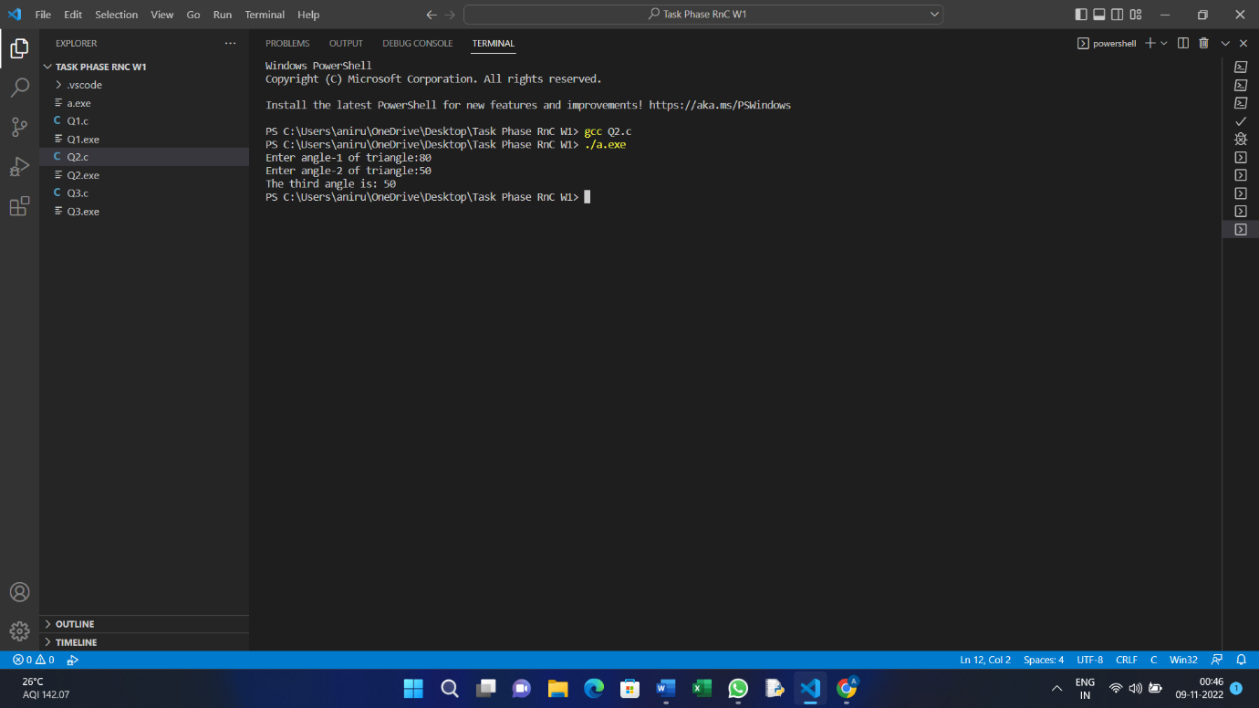

Q3] Write a C program to convert specified days into years, weeks and days. Note: Ignore leap year.

# Code:

#include <stdio.h>

int main(){

    int number_days, years, weeks, days;

    printf("Enter the number of days:");

    scanf("%d",&number_days);

    years=number_days/365;

    weeks=(number_days%365)/7;

    days=(number_days%365)-(weeks*7);

    printf("The number of years:%d\n",years);

    printf("The number of weeks:%d\n",weeks);

    printf("The number of days:%d\n",days);

    return 0;

}

# Output:

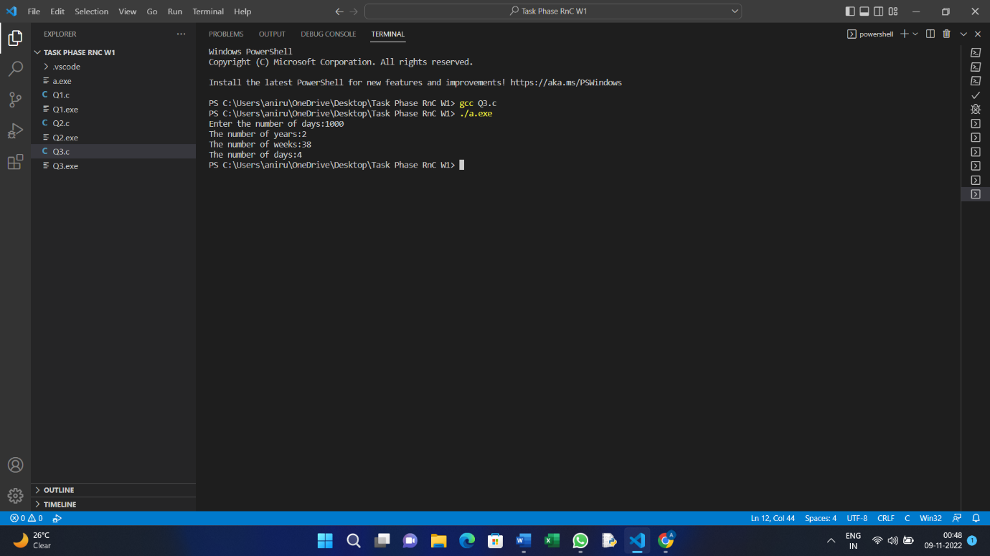

Q4] Reverse a given string/character array.

#Code:

#include <stdio.h>

#include <string.h>

void revstr(char*str);

int main(){

    char str[100];

    printf("Enter a string:");

    gets(str);

    printf("The string before reversing is: %s\n",str);

    revstr(str);

    printf("The reversed string is: %s\n", str);

    return 0;

}

void revstr(char *str){

    int len,t;

    len= strlen(str);

    for(int i=0; i<len/2; i++){

        t=str[i];

        str[i]=str[len-i-1];

        str[len-i-1]=t;

    }

}

#Output:

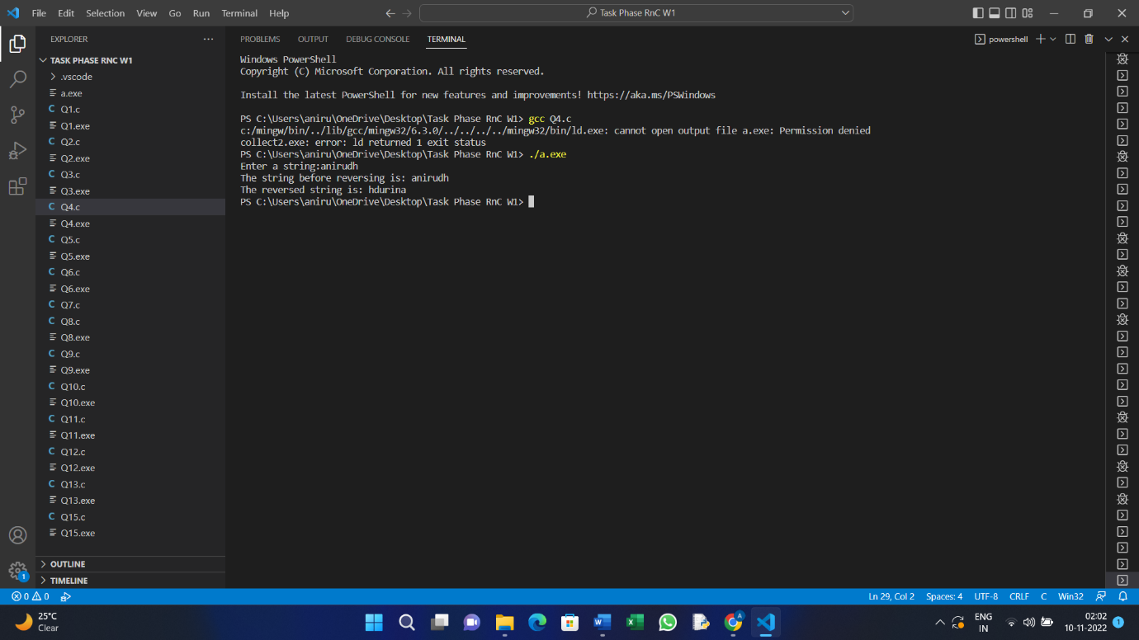

Q5] Write a C program to check if a triple is present in an array of integers or not. If a value appears three times in a row in an array it is called a triple.

#Code:

#include <stdio.h>

int main(){

    int arr[]={1,1,1,2,3,3,3};

    printf("Array is:");

    for(int i=0;i<7;i++){

        printf("%d,\t",arr[i]);

    }

    printf("\n");

    for(int i=0;i<4;i++){

        if(arr[i]==arr[i+1]==arr[i+2]){

            printf("A triple in present in the array!!");

            break;

        }

        else{

            printf("Triple not present in the array!!");

            break;

        }

    }

    return 0;

}

#Output:

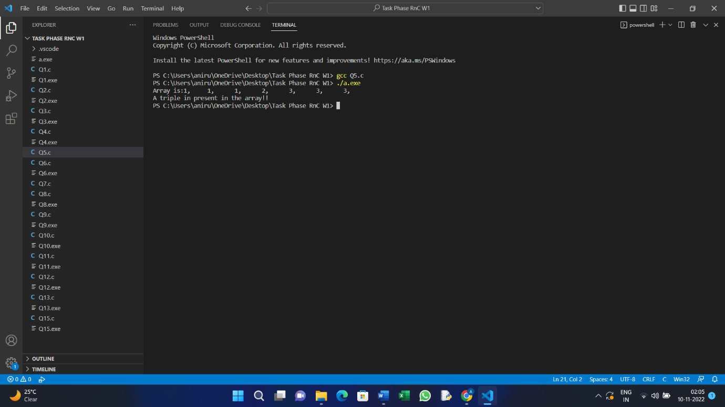

Q6] Write a C program to convert a string with numeric characters to an integer.

#Code:

#include <stdio.h>

#include <stdlib.h>

int main(){

    char str[]={'1','3','5','6','8'};

    int x;

    x= atoi(str);

    printf("The conveted string into integer is: %d",x);

    return 0;

}

#Output:

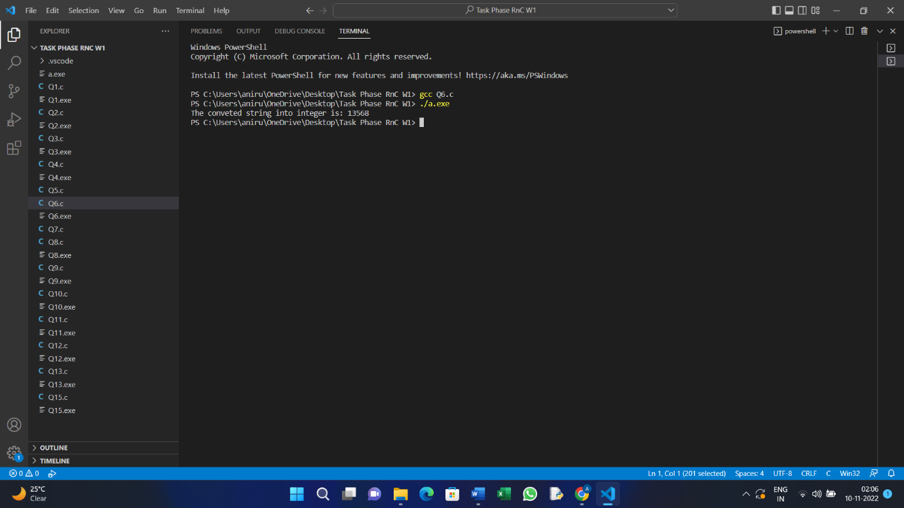

Q7] Write a C program to accept a coordinate point in a XY coordinate system and determine in which quadrant the coordinate point lies.

#Code:

#include <stdio.h>

int main(){

    int xcoordinate,ycoordinate;

    printf("Enter the x-coordinate:");

    scanf("%d",&xcoordinate);

    printf("Enter the y-coordinate:");

    scanf("%d",&ycoordinate);

    if(xcoordinate>0 && ycoordinate>0){

        printf("The point is in the first Quderant!");

    }

    else if(xcoordinate<0 && ycoordinate>0){

        printf("The point is in the second Quderant!");

    }

    else if(xcoordinate<0 && ycoordinate<0){

        printf("The point is in the third Quderant!");

    }

    else if(xcoordinate>0 && ycoordinate<0){

        printf("The point is in the fourth Quderant!");

    }

    else{

        printf("The point is at origin!");

    }

    return 0;

}

#Output:

Q8] Find the largest among 3 numbers using conditional operator(?:).

#Code:

#include <stdio.h>

int main(){

    int a,b,c;

    printf("Enter number1:");

    scanf("%d",&a);

    printf("Enter number2:");

    scanf("%d",&b);

    printf("Enter number3:");

    scanf("%d",&c);

    a>b && a>c ? printf("Biggest number is: %d",a): b>c ? printf("Biggest Number is: %d",b) : printf("Biggest number is: %d",c);

    return 0;

}

#Output:

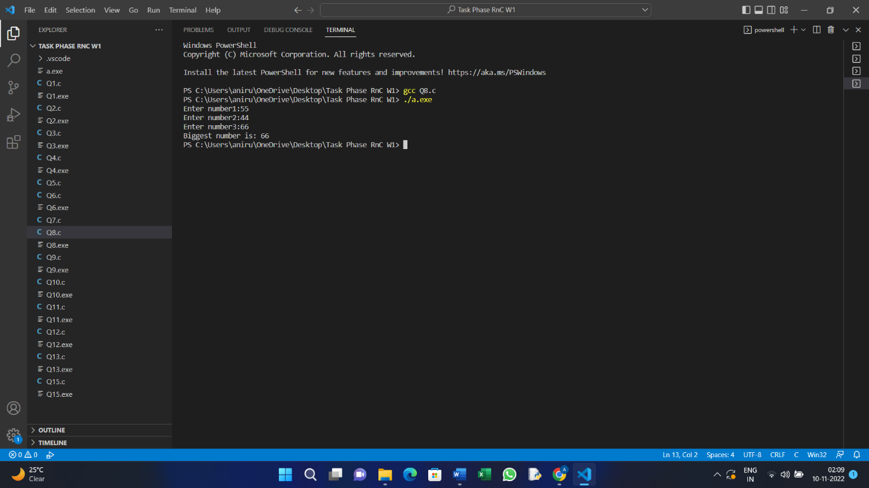

Q9] Write a program in C to display the multiplication table vertically from 1 to n.

#Code:

#include <stdio.h>

int main(){

    int n,m;

    printf("Enter number of which the table is required:");

    scanf("%d",&n);

    printf("Enter the number till where the table is required:");

    scanf("%d",&m);

    for(int i=1; i<=m; i++){

        printf("%d * %d = %d\n",n,i,n*i);

    }

    return 0;

}

#Output:

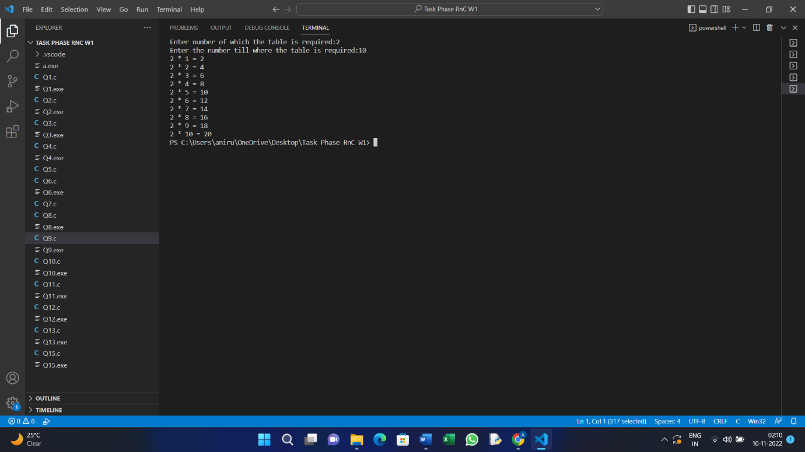

Q10] Write a program in C to print the Floyd's Triangle with n rows. If n=5 then the following is the output:

1

01

101

0101

10101.

#Code:

#include <stdio.h>

int main(){

    int n=5,p,q;

    for(int i=1;i<n;i++){

        if(i%2==0){

            p=1;

            q=0;

        }else{

            p=0;

            q=1;

        }

        for(int j=1;j<=i;j++){

            if(j%2==0){

                printf("%d",p);

            }else{

                printf("%d",q);

            }

        }

        printf("\n");

    }

    return 0;

}

#Output:

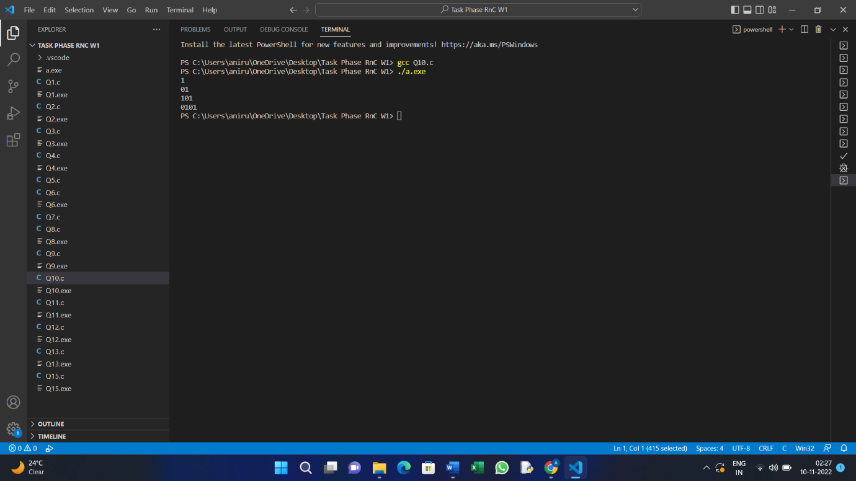

Q11] Write a program in C to separate odd and even integers in separate arrays.

#Code:

#include <stdio.h>

int main(){

    int arr1[100], arr2[100], arr3[100],n,j=0,k=0;

    printf("Enter number of elements to be added in array:");

    scanf("%d",&n);

    for(int i=0; i<n; i++){

        printf("Enter element %d:",i);

        scanf("%d",&arr1[i]);

    }

    for(int i=0; i<n; i++){

        if(arr1[i]%2==0){

            arr2[j]= arr1[i];

            j++;

        }

        else{

            arr3[k]=arr1[i];

            k++;

        }

    }

    printf("The even elements are:\n");

    for(int i=0; i<j;i++){

        printf("%d\n",arr2[i]);

    }

    printf("\nThe odd elements are:\n");

    for(int i=0; i<k;i++){

        printf("%d\n",arr3[i]);

    }

}

#Output:

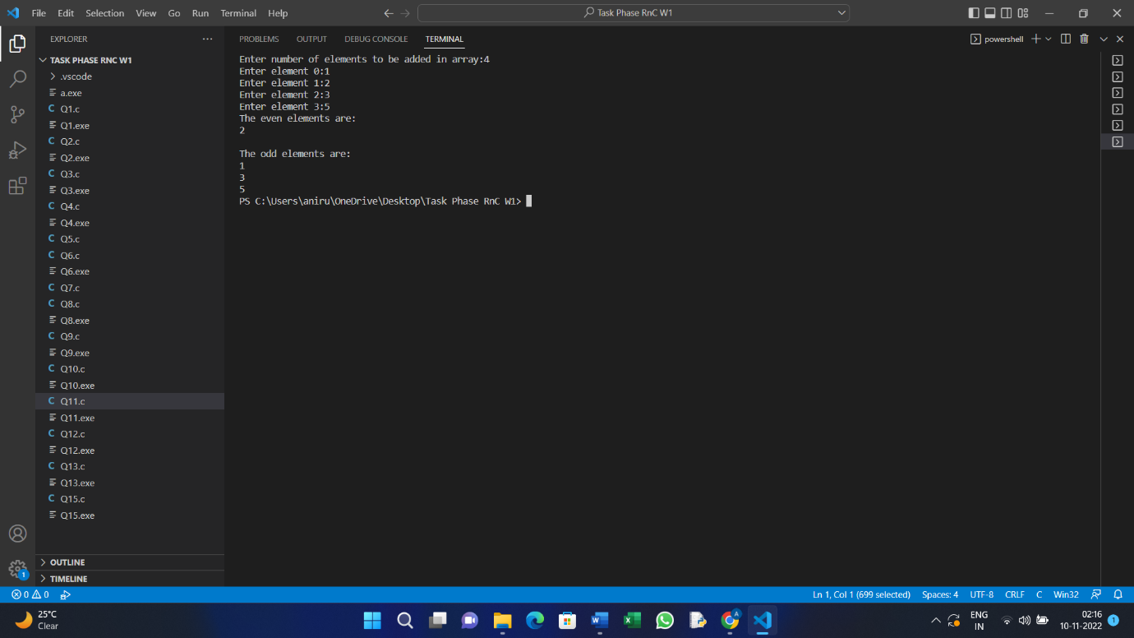

Q12] Write a program in C to find the maximum number between two numbers using a pointer.

#Code:

#include <stdio.h>

int main(){

    int firstno, secondno;

    int *first= &firstno;

    int *second= &secondno;

    printf("Enter First number:");

    scanf("%d",&firstno);

    printf("Enter second number:");

    scanf("%d",&secondno);

    if(*first>*second){

        printf("%d is the maximum number",*first);

    }

    else{

        printf("%d is the maximum number.",*second);

    }

    return 0;

}

#Output:

Q13] Write a C programming to repeatedly add all digits of a given non-negative number until the result has only one digit.

Example:

Input: 47

Output: 2

Explanation: The formula is like: 4 + 7 = 11, 1 + 1 = 2.

#Code:

#include <stdio.h>

int addDigits(int num) {

        return num - (num - 1) / 9 * 9;

    }

int main(){

    int n;

    printf("Enter a Number:");

    scanf("%d",&n);

    printf("The desired output is:%d",addDigits(n));

    return 0;

}

#Output:

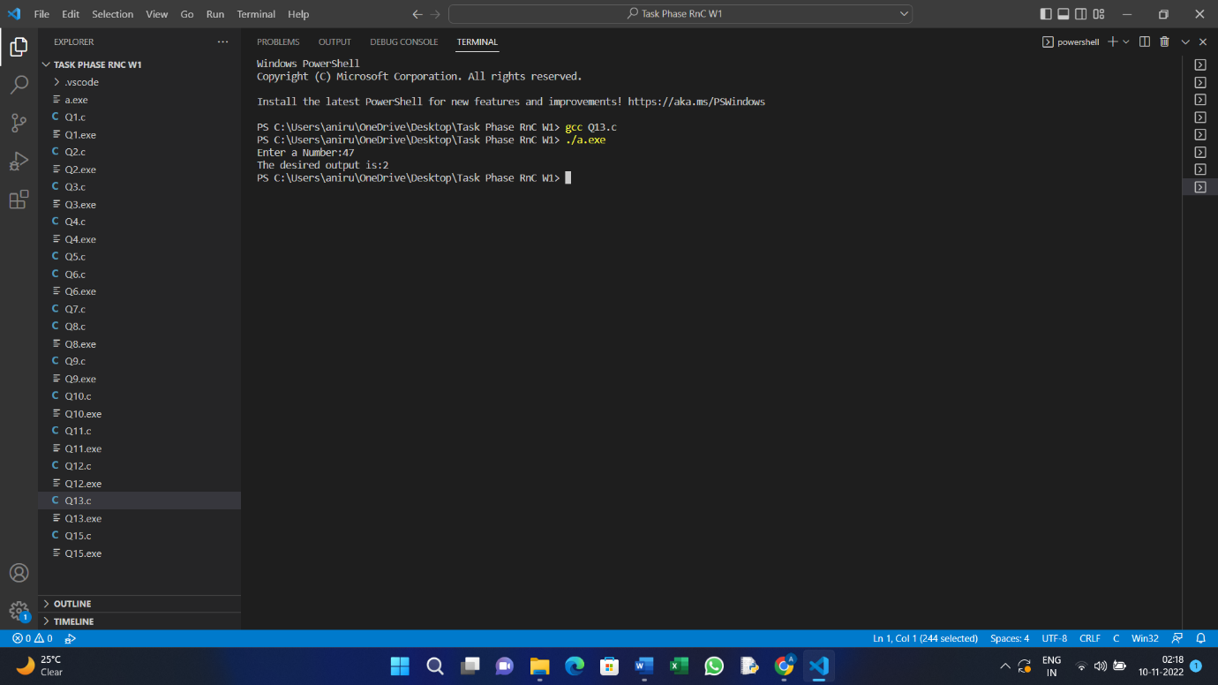

Q14] The prime factors of 13195 are 5, 7, 13, 29. Write a C program to find the largest prime factor of the number n taken as input from the user.

Code:

#include <stdio.h>

int main() {

   int n;

   n=546;

   int d=2, a= 0, maxfact;

   while(n!=0) {

      if(n % d !=0)

         d= d + 1;

      else {

         maxfact = n;

         n = n / d;

         if(n == 1) {

            printf("%d is the largest prime factor !",maxfact);

            a= 1;

            break;

         }

      }

   }

   return 0;

}

#Output:

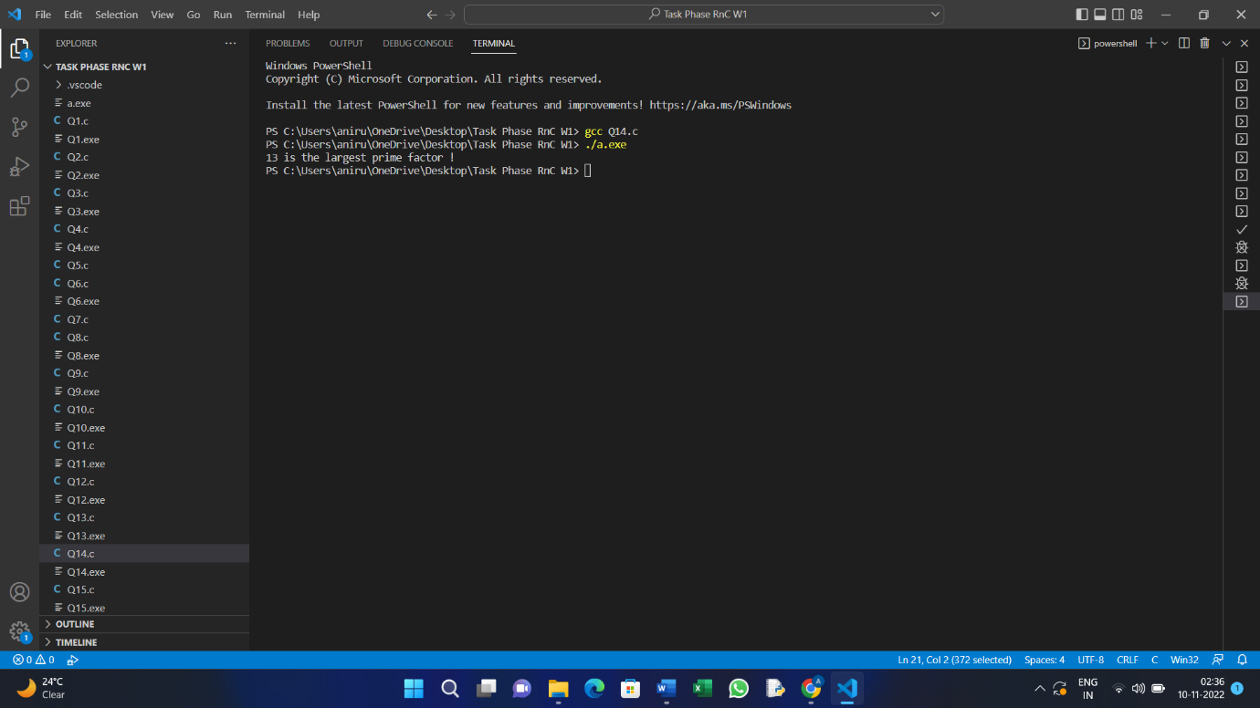

Q15] Write a C program to divide two given integers without using multiplication, division and mod operator. Return the quotient after dividing.

#Code:

#include <stdio.h>

int main(){

    int a,b,sum,t;

    printf("Enter number1:");

    scanf("%d",&a);

    printf("Enter number2:");

    scanf("%d",&b);

    sum=a+b;

    while(sum>b){

       sum=sum-b;

       t++;

    }

    printf("The Quotient is:%d",t);

    return 0;

}

#Output:

